

DEPARTMENT OF COMPUTER SCIENCE AND ENGINEERING

OPERATING SYSTEMS - CS235AI

REPORT

Submitted by

Skanda P R – 1RV22CS199

Computer Science and Engineering 2023-2024
Setting up MySQL Server in HPCC System:

Step 1: Install HPCC Cluster (Ignore if already installed)
In my case, I have downloaded the VM file to run the HPCC Cluster. The last version of HPCC cluster available is v8.2.0-1. You can download it from here: https://d2wulyp08c6njk.cloudfront.net/releases/CE-Candidate-8.2.0/bin/vm/HPCCSystemsVM-amd64-8.2.0-1.ova Also download and install Oracle VM Virtual Box. Open Virtual Box and click on File, and then Import Appliance, then select the path where you have downloaded the HPCCSystemsVM-amd64-8.2.0-1.ova file, then click Next and Finish. Then select the installed VM and click on settings. Go to Network Tab. In Adapter 1, select Attached to “NAT” and for Adapter 2, select Attached to “Host-only Adapter”. Click OK and double click to start the VM.
Step 2: Install MySQL Server
For installing MySQL server, follow the steps in this video: https://youtu.be/zRfI79BHf3k?si=4hVRc4XKiT4dV8p5
Step 3: Open ECL Watch and upload the csv data From the login page, copy the URL for ECL Watch and open it in a browser
In ECL watch navigate to Logical Files, Landing Zone. Here open Mydropzone and select upload.
After selecting upload, select the csv file to upload and click Finish. You will see the file name after uploading.
Step 4: Create Database and Table in MySQL
Open the VM and type following code sudo mysql -u root -p Then give the root password which you set while installing MySQL. You would have successfully connected to mysql server. Then type this code CREATE DATABASE test_db; USE test_db; CREATE TABLE test_tb( id int, cid float, pic50 float); In test_tb table, we have to create it based on the content in the csv file. I am using a csv file which has three attributes id, cid and pic50. Then you can either type “exit;” or keep it running in the background.

MySqlImport.ecl
This code outputs a single string as a result which contains a module that can be used to access all the tables in the MySql database. When we create a database called test_db in MySQL server using the command: CREATE DATABASE test_db; Then if we create a table using the command:

CREATE TABLE test(
id int,
cid float,
pic50 float);
Now if we run this ecl file, we will get the following output
IMPORT MySql;
EXPORT test_dbDatabase(string user, string password) := MODULE
EXPORT testRecord := RECORD
INTEGER4 id;
REAL4 cid;
REAL4 pic50;
END;
END;
This functionality is used to create multiple functions in the next file.

test_dbDatabase.ecl
This file contains different DML and DDL functions wrapped into a single module, so that the functions can be called directly in other file. It consistes of: * Creating new tables in MySQL server. * Inserting contents from CSV and XML files, which are stored in the HPCC Cluster, to MySQL table. * Storing the contents of MySQL table to a Logical file in HPCC Cluster. * Deleting content from MySQL table. * Deleting the MySQL table.

Function_Call.ecl
As the name of the file indicates, this file is used just to call the functions which were created in test_dbDatabase.ecl.

Incremental_Push_Function_Definition.ecl
Consider files order v1.csv and order v2.csv which has the content as follows:
order v1.csv
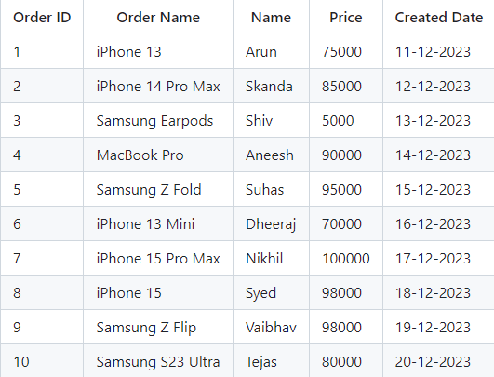

order v2.csv
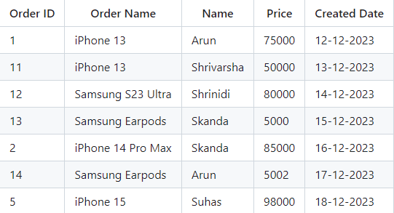
When these two files are merged, we should get an output like this:
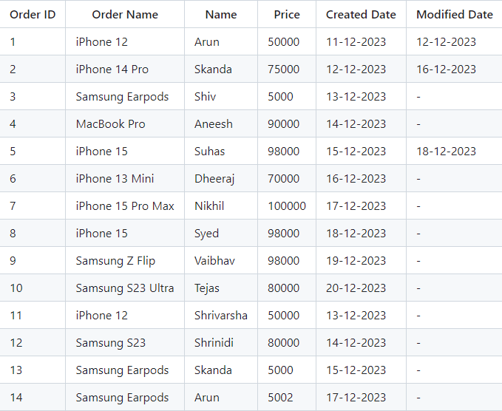

This is just an example, we can change the values in order version 2 CSV and still, the original table gets modified and gets stored in HPCC Cluster with logical name spr::order_modified. This is done using the functions defined in Incremental_Push_Function_Definition.ecl and these functions are called in Incremental_Push_Function_Call.ecl. In addition to this, we also get the outputs

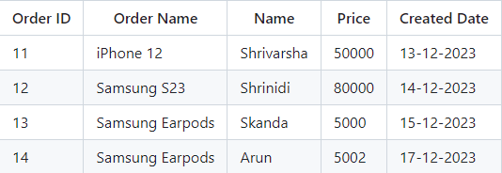

which specifies what new contents are added to the table and
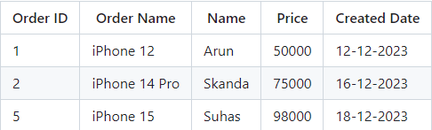

which specifies the content which is modified in the table, so that the user can get to know what changes are there in both the order versions. All these are carried out by calling the get(), get_added() and get_modified() functions which are present in Incremental_Push_Function_Definition.ecl file.

Setting up MySQL Server in HPCC System:

Step 1: Install HPCC Cluster (Ignore if already installed)
In my case, I have downloaded the VM file to run the HPCC Cluster. The last version of HPCC cluster available is v8.2.0-1. You can download it from here: https://d2wulyp08c6njk.cloudfront.net/releases/CE-Candidate-8.2.0/bin/vm/HPCCSystemsVM-amd64-8.2.0-1.ova Also download and install Oracle VM Virtual Box. Open Virtual Box and click on File, and then Import Appliance, then select the path where you have downloaded the HPCCSystemsVM-amd64-8.2.0-1.ova file, then click Next and Finish. Then select the installed VM and click on settings. Go to Network Tab. In Adapter 1, select Attached to “NAT” and for Adapter 2, select Attached to “Host-only Adapter”. Click OK and double click to start the VM.
Step 2: Install FTP Server and NANO text editor
For installing, run the following codes:
sudo apt install vsftpd
sudo apt install nano
Step 3: Configure vsftpd
Run the following command:
sudo nano /etc/vsftpd.conf
Now NANO text editor will open, use your arrow key and navigate to very end of file and then write this:
write_enable=YES
local_umask=022
chroot_local_user=YES
allow_writeable_chroot=YES
user_sub_token=$USER
local_root=/var/lib/HPCCSystems/mydropzone/$USER
Next click ctrl+O to write, ctrl+X to exit
Step 4: Allow ports from firewall to access FTP server
Run the command:
sudo ufw allow from any to any port 20,21 proto tcp

Step 5: Create a New User to access this FTP Server
Run the command:
sudo adduser user
Username you can keep anything, I am keeping it as user, also give a password.
Step 6: Create a folder in Landing Zone so that the user can access this Folder to upload the files
Run these commands:
sudo mkdir /var/lib/HPCCSystems/mydropzone/user
sudo chown nobody:nogroup /var/lib/HPCCSystems/mydropzone/user
sudo chmod a-w /var/lib/HPCCSystems/mydropzone/user
sudo mkdir /var/lib/HPCCSystems/mydropzone/user/upload
sudo chown user:user /var/lib/HPCCSystems/mydropzone/user/upload
echo "My FTP Server" | sudo tee /var/lib/HPCCSystems/mydropzone/user/upload/demo.txt
Just check in the ecl watch dropzone if demo.txt is available
Step 7: Restart FTP Server
Run these commands:
sudo systemctl restart vsftpd
sudo service vsftpd status
Check if the FTP Server Status is Active. If it isn’t, run these commands:
sudo apt purge vsftpd
sudo apt install vsftpd
sudo nano /etc/vsftpd.conf
Now nano text editor will open, use your arrow key and navigate to very end of file and then write this
write_enable=YES
local_umask=022
chroot_local_user=YES
allow_writeable_chroot=YES
user_sub_token=$USER
local_root=/var/lib/HPCCSystems/mydropzone/$USER
Next click ctrl+O to write, ctrl+X to exit. Now run these commands to check the Status again:
sudo systemctl restart vsftpd
sudo service vsftpd status
Now the status will be Active Next run:
hostname -I
Note down the IP Address of the FTP Server.
Step 8: Install FileZilla in windows to access FTP Server
Download and Install FileZilla from this link: https://filezilla-project.org/download.php?type=client. After installing, open it, enter Host as the IP address, Username as user which you created, Password as the password which you set in installation, then click Quick Connect button, you will see the upload folder, inside it you can see the demo.txt, here you can upload any file from Windows to FTP server, which adds it to landing zone of HPCC cluster. You can go to ecl watch and verify the same.

